# Your Name: ________________________________ Student Number: _______________________

# Lab 8a: to be done in class with a partner – due at the end of this lesson

# ProvinceTerritory

Create a class called ProvinceTerritory. It contains two instance variables: a String name and an int population. Create accessors and mutators too. The constructor takes the name and population as parameters and sets them as long as the name isn’t null and the population isn’t negative.

# Canada

Create a class called Canada. It contains an array of 13 ProvinceTerritory references:

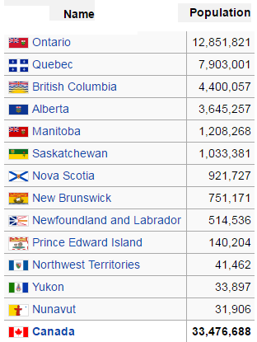

Populate the array inside the Canada constructor. The following code will be useful:

**public static final int BC = 0;**

**public static final int AB = 1;**

**etc...**

**provinces[BC] = new ProvinceTerritory("british columbia", 4400057);**

**provinces[AB] = new ProvinceTerritory("alberta", 3645257);**

**etc...**

Create a method called **public int getTotalPopulation()** which uses a loop to add up all of the individual populations to calculate Canada’s total population.

Create a method called **public String getLowestPopulation()** which uses a loop to determine and return the name of the province/territory that has the lowest population.

Create a method called **public int getPopulation(String province)** which returns the population of the province (the parameter); if there is no such province, return a constant called NO_SUCH_PROVINCE, which is an int set to -1.

Demonstrate your completed project to your instructor. When your instructor is satisfied, your paper will be signed and you can go home. Lab 8b (below) is due at the next lesson, and there is also a quiz next day.

Checked by: ______________________________________

**NOTE:** keep this paper for your instructor to verify your grades later in the course.

NOTE: EVERY SINGLE STUDENT MUST SUBMIT THIS LAB AND GET HIS OR HER PAPER SIGNED….

# Lab 8b: at home, alone – due next class (in person at the end of NEXT lab)

Continue with the Canada class you made in lab 8a, above.

Here is an example method called **public String[] getProvincesWithPopulationBetween(int min, int max)** which returns an array of the names of all provinces/territories that have a population between min and max (inclusive):

public String[] getProvincesWithPopulationBetween(int min, int max){

int i = 0;

int j = 0; // the new array index

int numOfProvWithPop = 0;

String[] matchingProvinces;

while(i < provinces.length){

if((provinces[i].getPopulation() >= min) &&

(provinces[i].getPopulation() <= max)){

numOfProvWithPop++;

}

i++;

}

if(numOfProvWithPop > 0){

matchingProvinces = new ProvinceTerritory[numOfProvWithPop];

}else{

// no matches

return null;

}

i = 0; // start looking from the beginning again

while(i < provinces.length){

if((provinces[i].getPopulation()>= min) &&

provinces[i].getPopulation()<= max)){

matchingProvinces[j] = provinces[i];

j++;

}

i++;

}

return matchingProvinces;

}

}

Create a method called **public boolean isProvinceInCanada(String name)** which returns true if there is a province/territory in Canada with the given name (the parameter); otherwise returns false.

Create a method called **public String[] getProvincesWhoseNameContains(String substring)** which returns an array of the names of all provinces/territories whose name contains substring (the parameter). Hint: use the String class’s **contains()** method.

Create a method called   
**public ProvinceTerritory[] getMoreProvincesWhoseNameContains(  
 String substring)**   
which returns an array of the names of all provinces/territories whose name contains substring (the parameter). Hint: use the String class’s **contains()** method.

Create a method called **public String[] getProvincesWhoseNameStartsWith(char letter)** which returns an array of the names of all provinces/territories whose name starts with letter (the parameter). Hint: use the String class’s **startsWith()** method or use the String class’s charAt(0) method.

This take-home lab is due next class. Finish it before next class (on your own…no partner) and bring it in person so your instructor can review it with you during the lab period after the lecture. Do not upload your lab to BCIT’s server.

Checked by: ______________________________________

**NOTE:** keep this paper for your instructor to verify your grades later in the course.

NOTE: EVERY SINGLE STUDENT MUST SUBMIT THIS LAB AND GET HIS OR HER PAPER SIGNED….